
Oldham Boxing - Equality Policy 23/24

Oldham Boxing is committed to ensuring Equality throughout our establishment and that all staff members adhere to our Equality Policy. We do not discriminate against age, gender, race or religion.
Staff
Our staff is of mixed gender-we have both male and female fitness coaches/mentors.
All staff are given the same opportunity to progress within the organisation and provided with as much training as possible for their own personal development.
Trustees
We welcome male and female trustees to ensure an equal balance. At present we have a male board of Trustees and one female on the board of trustees.
Volunteers
Again, Oldham Boxing volunteers are made up from mixed genders and ages who are given equal responsibilities and experiences, both in the gym and in the office. All volunteers are DBS checked to safeguard our service users.
Participants.
All genders are welcome at Oldham Boxing, we provide classes to cater for different needs and some classes are put on especially for different genders e.g. Women only classes. This is due to requests from individuals who feel more comfortable in gender specified classes.
Boxing
We have both male and female participants within our boxing classes.

Approved by Chairman of Committee
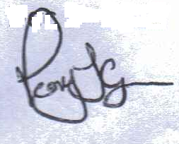 30/05/23

